The Love That Forgives and Won’t Let Go

AnswersFromScriptureOnline.com

Forgiveness is a deep personal need. It is not just a theological concept—it is the heartbeat of heaven and the personal gift God extends to every soul. Through Scripture, we see a forgiveness flows from a God who pursues us relentlessly, not to condemn, but to restore. He doesn’t wait for us to get it all together; He meets us in our brokenness, and we are all broken.


From the first fall to the foot of the cross, the story of the Bible is the story of the One who loves us and who refuses to give up on us. The cost of Forgiveness was exposed at Calvary, but it was promised in Genesis, foreshadowed in the sanctuary, thundered from Sinai, and whispered in the quiet of a broken heart. It reaches everyone: from the lost and lonely people looking for a home to royalty in palaces, and to you.

Forgiveness in Jesus is not merely a divine pardon—it’s a personal invitation.

Jesus says, “Come to Me, all you who labor and are heavy laden, and I will give you rest” (Matthew 11:28, NKJV).

He doesn’t just blot out our sin; He offers to heal our hearts and walk with us into a transformed future.

Changed by Forgiveness: Zacchaeus, Mary, and Peter

Zacchaeus was a tax collector—despised, corrupt, and spiritually empty. Yet when he heard Jesus was coming, something stirred. He climbed a tree just to see Him. What did Jesus do? He looked up and said, “Zacchaeus, make haste and come down, for today I must stay at your house” (Luke 19:5, NKJV).

The result? Zacchaeus declared: “Lord, I give half of my goods to the poor; and if I have taken anything from anyone by false accusation, I restore fourfold” (Luke 19:8, NKJV). Jesus responded, “Today salvation has come to this house” (Luke 19:9). Forgiveness transformed a greedy heart into a generous one.

Mary Magdalene was once bound by darkness—Jesus cast out seven demons from her (Luke 8:2). She had a painful past, yet she became one of Christ’s most devoted followers. It was Mary who anointed Jesus with costly oil, wiping His feet with her tears and hair (Luke 7:38). When criticized, Jesus said, “Her sins, which are many, are forgiven, for she loved much. But to whom little is forgiven, the same loves little” (Luke 7:47, NKJV).

Mary’s love wasn’t a performance—it was a response. Forgiveness gave her back her dignity, her identity, and her future.

Peter, bold but flawed, denied Jesus three times when fear overcame him. After the resurrection, Jesus asked him not once, but three times, “Do you love Me?” (John 21:15-17). Each time Peter answered yes, and Jesus commissioned him, “Feed My sheep.”

Peter’s guilt was not the end of his story. Forgiveness led him to preach powerfully at Pentecost, when three thousand souls were baptized (Acts 2:41). Jesus’ love didn’t discard him—it restored him.

Forgiveness Is for You—Right Now

These are not abstract stories. These are the stories of real people, with real sin, who found real forgiveness—and so can you.

Jesus still sees the hearts that climb trees to catch a glimpse of hope. He still defends the broken who weep at His feet. He still meets those who’ve denied Him and calls them by name.

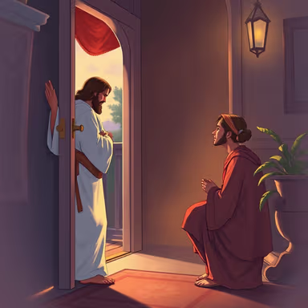
“Behold, I stand at the door and knock. If anyone hears My voice and opens the door, I will come in to him and dine with him, and he with Me” (Revelation 3:20, NKJV).

Forgiveness begins the moment we turn toward Him. It’s not earned. It’s received. Jesus isn’t waiting for your perfection—He’s knocking at your door right now.

So today, open your heart. Let Him in. Say yes to His love. Say yes to His mercy. Say yes to a forgiven life.

Because the truth is, you’re not too far, and it’s not too late.

